**Special Education Update 3/13/2020 12:00pm**

We will provide more explicit guidance about what your workday might look like during the webinar Friday afternoon and on Monday.

**Special education Free & Appropriate Public Education (FAPE) requirements**

**What do district-wide supports include and not include?**

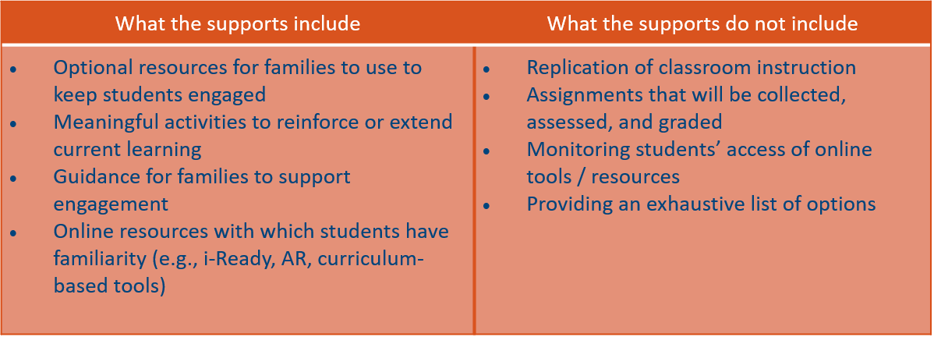

**How will student’s eligible for special education services access a Free & Appropriate Public Education (FAPE)?**

* Using the same modalities as the district-wide student engagement and learning support resources, there will be special education specific student engagement and learning support resources
  + The first two weeks of resources have been created by department staff and related services team leads
  + You will receive information at Friday afternoon’s webinar and Monday’s training
  + Special services will provide a zoom meeting on Monday afternoon

**Will Everett provide special education and related services as outlined in the individual education plans (IEPs) through a distance learning model?**

* ***Based on OSPI guidance, we are not replicating classroom instruction which is the same for special education and related service delivery. We are not replicating IEP minutes and not providing direct services.***
* IF core content replicates classroom instruction THEN we will need to replicate each of the 2,533 student’s special education and related services IEP minutes.

**Will annual individual education plan (IEP) and triennial reevaluation meetings be held within the timelines?**

* Following OSPI guidance, Everett will hold IEP and reevaluation meetings through a mutually agreed upon method (via phone and/or video conference)
* All team members need to participate and/or an excusal form must be electronically signed
* The district will provide guidance on administering assessments to complete the reevaluation during school closure

**Will active referrals and initial evaluation be held when school is closed?**

* No, referrals and initial evaluation timelines are based on “school days” so the timeline stops the first day the school is closed (3/16/2020) and will start when school opens (anticipated date 4/27/2020)

**What can we send home with students?**

* Reference ESY recommendations when determining materials needed to maintain current skills
* You can send home items that you would typically send on a weekly basis and/or during vacations and holidays
* Any visual supports students are using with their daily instructional routine
* AAC – any communication devices that students are independently using can be sent home regardless of the signed authorization

*Please do not send home trial or newly implemented devices*

**What will happen to in-district agency contract service providers**

* At this time, Everett will maintain current contracts and pay in-district contract providers
* Contract providers need to sign in and out and will focus on training, classroom prep, and other duties as assigned within district

**What does communication to families look like?**

* A letter will be sent to families explaining the district plan. This letter will

(1) reinforce that the closure does not excuse the fulfillment of FAPE,

(2) offer parents an opportunity to attend IEP meetings and/or point of contact for questions, and

(3) be shared with special education staff, school and district administrators, and others before sending out to families

* If you receive questions about instruction or services, please refer families back to the content of the letter and, if necessary, direct them to special services